**Step 1:** Create **Loan Prediction** folder in Google drive.

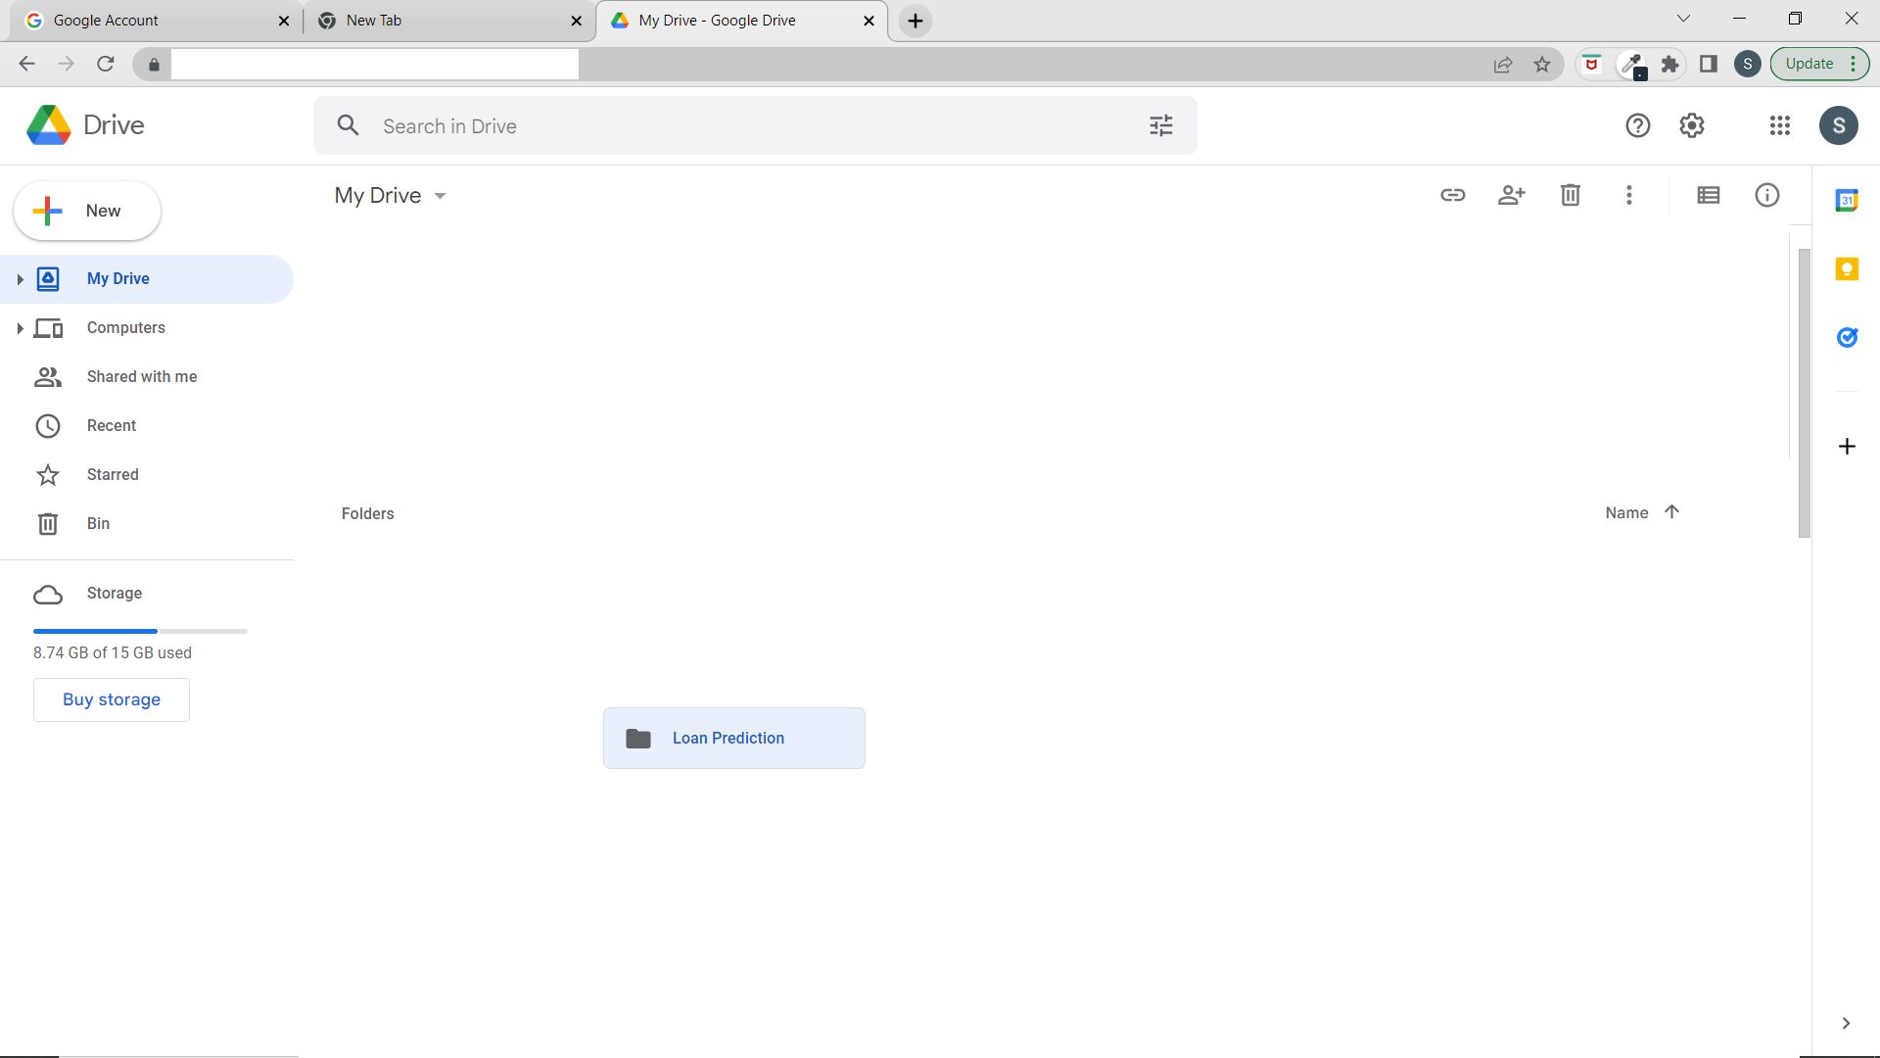

**Step 2:** Create **Data Files and Model Training** Folder in Loan prediction folder.

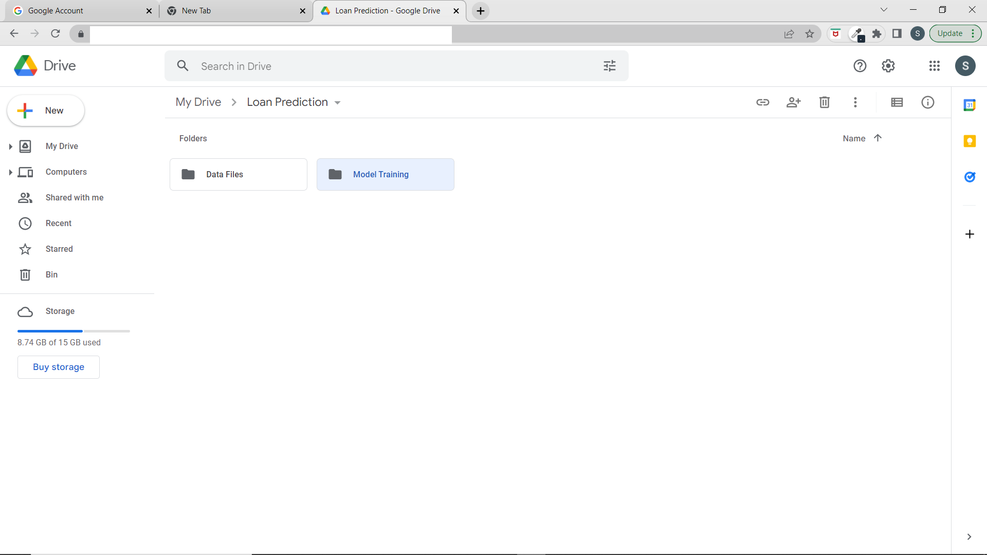

**Step 3: C**opy **train csv** file in Data Files folder in local device and paste it in Data Files in Google Drive.

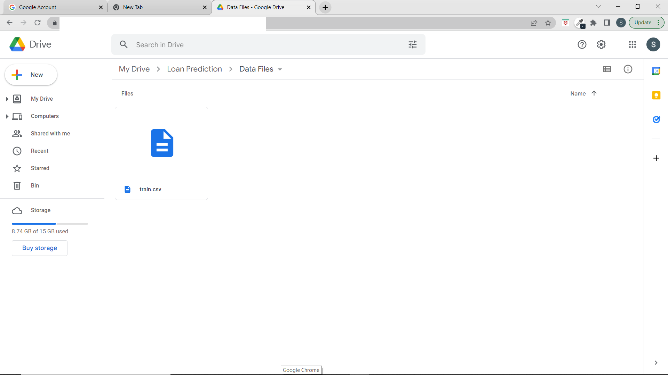

**Step 4: Copy** all files in Model Training from local and paste all files in Model Training in Google drive.

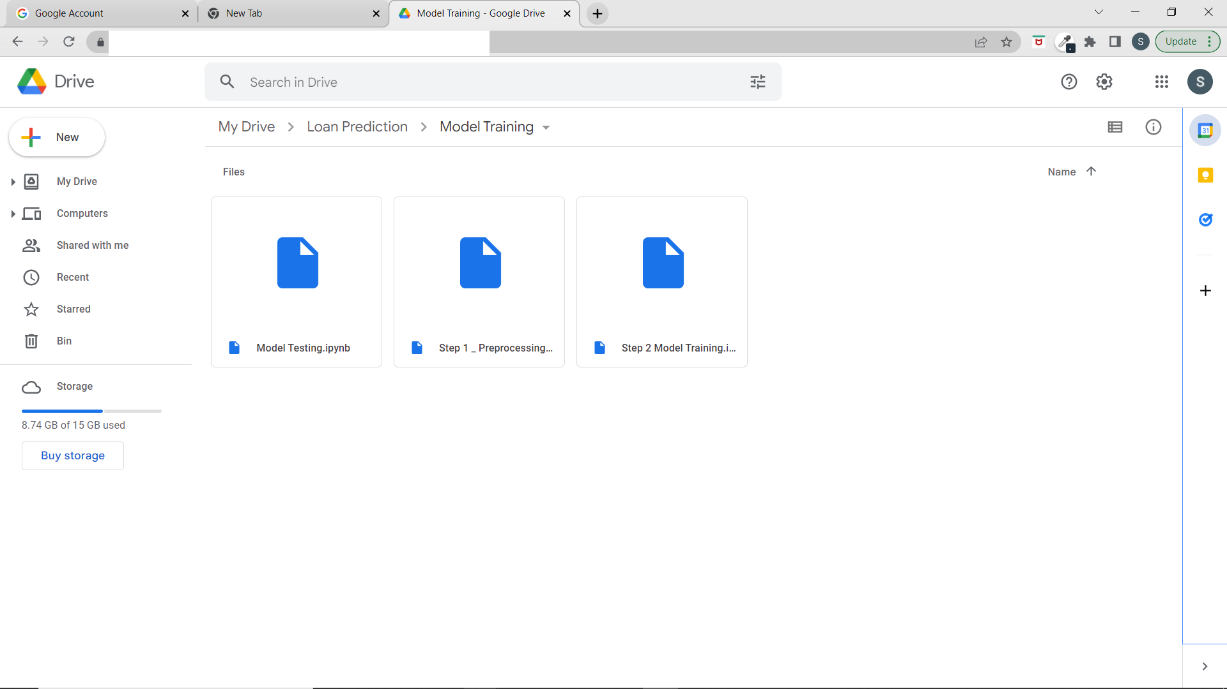

**Step 4:** Run Data Preprocessing File. After running this file, processed **file csv** will be stored in the Data Files folder.

**Step 5:** Run Model Training File. After running this file all trained model files will be stored in Data Files Folder.

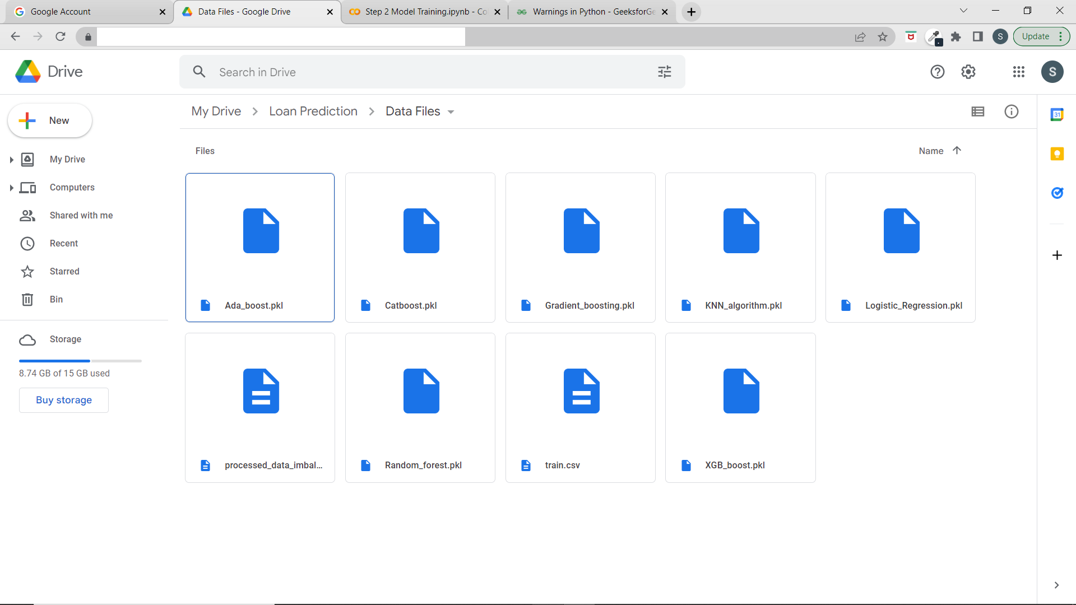

**Step 6:** Copy all model Files in Google drive and paste these model files in data files folder in local device.

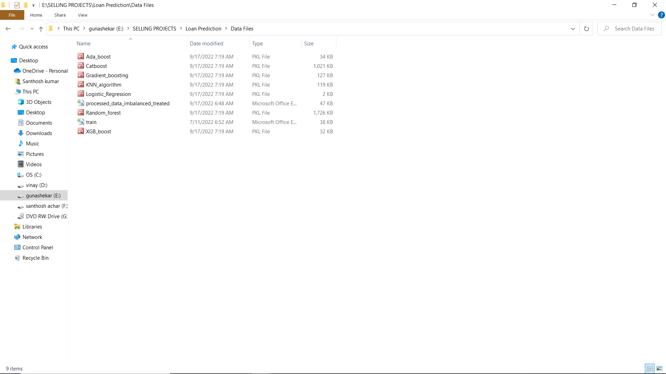

**Step 7: Open command prompt and working directory should be the root folder of the project.**

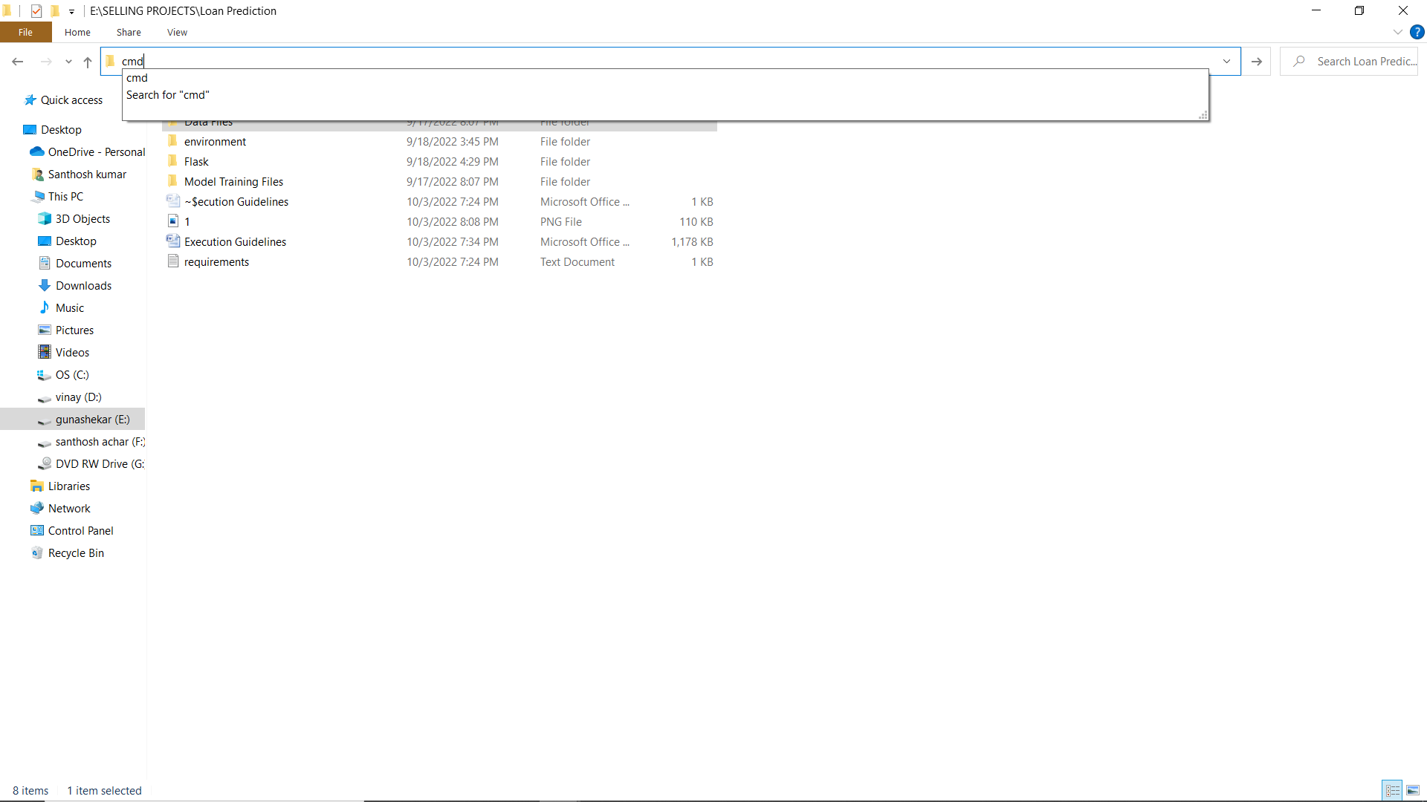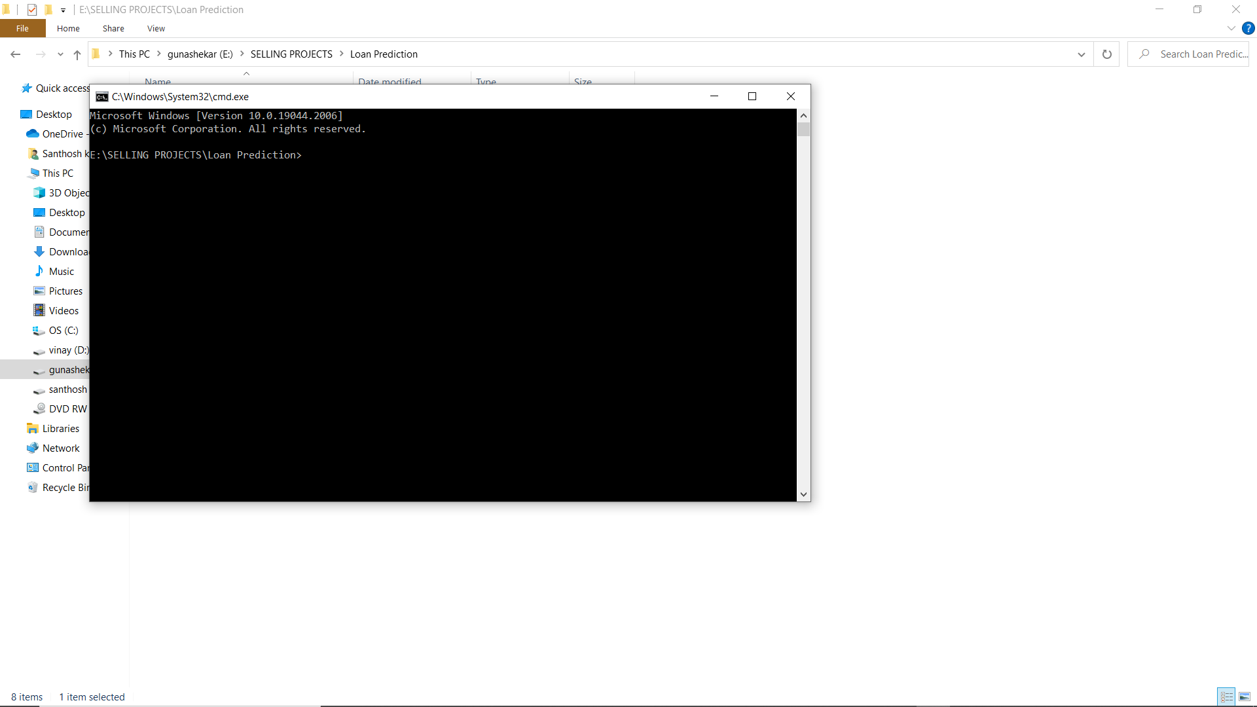

**Step 8: Create virtual environment.**

1. pip install virtualenv
2. virtualenv environment
3. environment\scripts\activate

**Step 9: Install required packages.**

1. pip install –r requirements.txt.

**Step 10: change the working directory to flask.**

1. cd Flask

